**PROJECT REPORT**

**SMART RFID KAMSIS SYSTEM AT PTSS**

NURUL IZZAH `ATHIRAH BINTI ZAMURI 18DDT18F1075

MUHAMMAD HAFIZ BIN ZAKARIA 18DDT18F1034

**DEPARTMENT OF INFORMATION TECHNOLOGY**

**& COMMUNICATION**

POLITEKNIK TUANKU SYED SIRAJUDDIN

JUN 2020

SMART RFID KAMSIS SYSTEM

**Table of Contents**

PAGE

1.0 PROJECT PLAN

1.1 Introduction 1

1.2 Problem Statement  2

1.3 Objective of Project **2**

1.4 Scope of Project

1.4.1 System Scope 2

1.4.2 User Scope 3

1.4.3 Location Scope 3

1.4.4 Software Scope 4

1.4.5 Hardware Scope 4

1.5 Literature Review

1.5.1 Significant Project 5

1.5.2 Literature Signifiant 5

1.5.3 System 6

1.5.4 Web Based 6

1.5.5 Database 6

1.5.6 System Comparison 7-10

1.6 Methodology of Project

1.6.1 Introduction 11

1.6.2 Rapid Application Development (RAD) 11

1.6.3 Rapid Application Development Phase 12

1.7 Project Gantt Chart 13

**2.0 REQUIMENT SPECIFITION**

2.1 Functional Requiment 14

2.2 Non Functional Requiment 14

2.3 Hardware and Software Requiment 15

2.4 System Configuration 16

2.5 Security Requirement /Exceptional Handling 16

3.0 **FINAL DESIGN**

3.1 Logical Design 17-18

3.2 Physical Design 20-36

4.0 **TEST DESCRIPTION AND RESULT**

4.1 Unit Testing Plan 37-38

4.2 Integration Testing Plan 39-40

5.0 **DISCUSSIONS**

5.1 Advantage of the Project 40

5.2 Limitation of the Project 40

6.0 **CONCLUSIONS AND RECOMMENDATIONS**  41

7.0 **REFERENCE**  42

LIST OF FIGURE

PAGE

1.0 PROJECT PLAN

Figure 1.0 LocationPoliteknikSyedTuankuSirajuddin 3

Figure 1.1 RFID Door lock 7

Figure 1.2 Personal RFID lock 7

Figure 1.3 Rapid Application Development 11

Figure 1.4 Grantt Chart 13

3.0 **FINAL DESIGN**

|  |  |
| --- | --- |
| Figure 3.0 Data Flow Diagram | 17 |
| Figure 3.1 Crow Foot | 18 |
| Figure 3.2 Flow Chart | 19 |
| Figure 3.3 Admin login | 20 |
| Figure 3.4 Admin Profile | 20 |
| Figure 3.5 Dashboard Admin | 21 |
| Figure 3.6 Setup Student Room | 21 |
| Figure 3.7 Manage Room | 22 |
| Figure 3.8 manage Registred Student | 22 |
| Figure 3.9 Acces Log | 23 |
| Figure 3.10 Login Interface Staff | 24 |
| Figure 3.11 Dashboard staff | 24 |
| Figure 3.12 Manage Registred Student | 25 |
| Figure 3.13 Manage Facilities | 25 |
| Figure 3.14 Add a Room information | 26 |
| Figure 3.15 Manage Facilities | 26 |
| Figure 3.16 Manage Registred Student | 27 |
| Figure 3.17 RFID scan | 27 |
| Figure 3.18 Disable Access Card | 28 |
| Figure 3.19 Access log | 28 |
| Figure 3.20 Student Register | 29 |
| Figure 3.21 Student Login | 29 |
| Figure 3.22 Annoucement | 30 |
| Figure 3.23 Dashboard Student | 30 |
| Figure 3.24 Student Profile | 31 |
| Figure 3.25 Room Details | 31 |
| Figure 3.26 Successfully card | 31 |
| Figure 3.27 Confirmation Infromation | 32 |
| Figure 3.28 Successfully | 32 |
| Figure 3.29 Confirmation already use | 32 |
| Figure 3.30 Room Details | 33 |
| Figure 3.31 Activate lock key | 33 |
| Figure 3.32 Ready to use | 33 |
| Figure 3.33 Change Password | 34 |
| Figure 3.34 Access Login | 34 |
| Figure 3.35 Access Lock Key | 34 |
| Figure 3.36 hardware component | 35 |
| Figure 3.37 hardware component | 35 |
| Figure 3.38 hardware component | 36 |
| Figure 3.39 hardware component | 36 |
| Figure 3.40 Result Testing | 39 |

LIST OF TABLE

PAGE

1.0 PROJECT PLAN

Table 1.1 Software Scope 4

Table 1.2 Hardware Scope 4

Table 1.3 RFID Door Lock 10

2.0 REQUIREMENT SPECIFICATION

2.1 Software 15

2.1 Hardware 15

4.0 TEST DESCRIPTION AND RESULT

Table 4.1 Web System Integration testing Plan 38-39

Table 4.2 Integtration Testing Plan 40

1.0 **PROJECT PLAN**

* 1. INTRODUCTION

Tuanku Syed Sirajuddin Polytechnic is an IPTA located in Arau Perlis and is the 18th polytechnic in Malaysia. This polytechnic was formerly known as Perlis Polytechnic. At the polytechnic is a student residential college, every year there will be two semesters of study that take place in December and June.

The warden suggested a system to update the data of each occupant of the room and the inflow and outflow of occupants from the room. The system that is going to be done is based on web based . Meanwhile, the web based helps user register the data such as student can confirm facilities details for check by staff and admin.

There are only 3 users in this system, namely Hal ehwal pelajar(HEP) ,residential college wardens and students

This system is created to overcome some problems that are:

1) Residential college warden: wants to reduce the cost of making locks every semester when there is a loss and negligence.

2) Students: face difficulties if keys are lost and room security is not tightly controlled.

The Polytechnic is committed to providing facilities for each occupant of the room as well as maintaining the safety of occupants in the event of intrusion or unwanted theft.

1

**1.2 PROBLEM STATEMENT**

Each semester the room key will be reduced among residents kamsis because lost and negligence. This is a problem for the warden kamsis as difficult for a new manufacturing process for the next semester because each semester will turn new residents.There are some significant negative consequences if a key is not returned or are lost due to the negligence of both parties. One effect is the warden had to create a new key so that new residents can enter the room.

**1.3 OBJECTIVE**

The main objective of SMART RFID KAMSIS SYSTEM AT PTSS.

- to manage room facilities information

- to control room authorization

- to alert users about unlock doors

**1.4 Scope**

There are 5 types scope such as system scope, user scope, location scope, hardware scope and software. Below is the explanation for five scopes.

**1.4.1 System Scope**

System scope that we are developing by using Notepad Plus, Java, Arduino IDE, Xammp server Mysql. This system is help the warden of the kamsis politeknik to update room Student and access matrix cards as room keys.

There are three types of users in this system.Each of the user will have its own functionality. Admin be able to update or remove data occupants with using the system for each semester.Also, able to reset username and view all the updates that is updated by the admin. Second,Warders can update the students details about facilities.After that,warden can view student information.

Third is room occupants. Room Occupants can confirm the facilities room and view own information.

2

**1.4.2 User Scope**

I) Admin

HEP is the admin of the system.The admin of the company is able to update and remove user of the system

ii ) Staff

Warden kamsis is the staff of the system.The staff can view student info and update details about facilities room.

iii ) Student

Student is able to open the door with matrik card.Also, .Can confirm the facilities room and also can view the own information.

**1.4.3 Location scope**

This system will implement at Politeknik Tuanku Syed Sirajuddin, Pauh, Perlis.

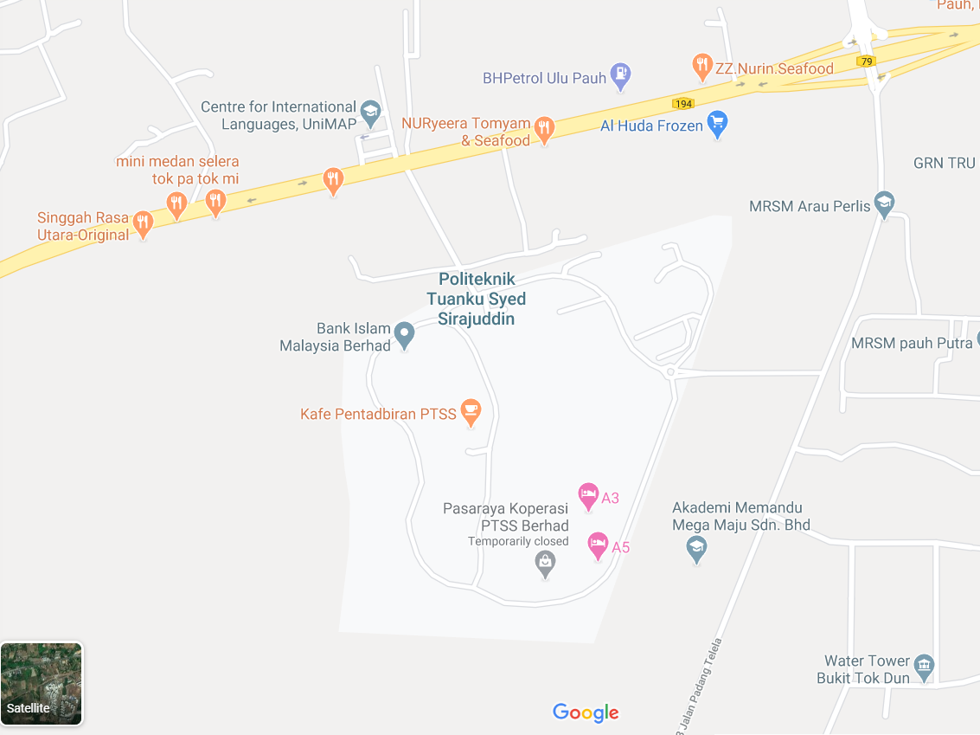

Figure 1.0 Location Politeknik Tuanku Syed Sirajuddin

3

**1.4.4 Software Scope**

To produce this system, there are some software used as in the table 1 below:

Table 1.0: Software

|  |  |
| --- | --- |
| **Software** | **Explaination** |
| Arduino IDE | Program And set up Arduino Uno |
| Notepad Plus | To create web based interface |
| Xammp Server Mysql | Create Database |

**1.4.5 Hardware Scope**

Table 1.2 : Hardware Scope

|  |  |
| --- | --- |
| Hardware | Explaination |
| 1. MRFC RFID522 RFID Scanner | To read RFID card |
| 1. 12V DC Solenoid Door Lock | electrical locking and unlocking |
| 1. Nodemcu EPS8266 | To control a digital output |
| 1. 2Channel Isolated 5V Relay(BT13-003) | allows a relatively low voltage to easily control higher power circuits |
| 1. breadboard | make quick electrical connections between components |
| 1. Jumper cable 150mm | open or bypass part of an electronic circuit |
| 1. 12V Battery | Supply power to Arduino |
| 1. Led | Light will on went solenoid open |
| 1. Buzzer | Turn on door is open |
| 1. Pine wood | For design door |
| 1. Pir sensor | PIR sensors are commonly used in security alarms and automatic lighting applications. |

4

**1.5 Significant Project**

This Smart RFID kamsis saves time and reduces the cost of resetting the lock in the event of a loss while providing a better solution for the safety of each occupant of the room. Admin will update and delete the occupant data student.Second, staff can view students details and add facilities details student room. Third, Student can confirm the facilities room at web based. If in one room there are 2 occupants, only the 2 occupants can access the rfid lock system .

**1.5.1 Literature Signifiant**

The main purpose of the literature review is to study the problem and assess the existing system, or any activity related to the projects to be developed. Collect information about the Smart RFID Kamsis Lock Door system, the system requirements and priority system should also be investigated. An interview with Warden Asrama Politeknik Tuanku Syed Sirajudin has done to collect information and to understand the Student,s requirements. Knowledge of kamsis key system information can also be gathered from observation and interview sessions.It will be easier for programmer to develop Smart RFID Kamsis Lock Door system.

Kamsis Politeknik Tuanku Syed Sirajudin have own record system ,so records on Website Ikamsis to book a room is the only method used for students to record all personal information and room information.

Moreover, comparisons between previous room lock systems can in Kamsis Politeknik Tuanku Syed Sirajudin also helps the developer to get some idea to determine the functions in new system

Furthermore, the study of literature is important in developing a project. It is done to collect various information related to the project in which this information will serve as guidelines and provide a clear picture of the project to be develop.

5

**1.5.2 System**

System design includes activities to conceive a system that answers an intended purpose, using principles and concepts, it includes assessments and decisions to select elements that compose the system, fit the architecture of the system, and comply traded-off system requirements. System design is the complete set of detailed models, properties or characteristics described into a form suitable for implementation .

The main System of RFID Kamsis system is use the database from Student,that can access by Admin(HEP) and Warden(staff).If Room has been book by Student ,the lock door will manually set up information about that student’s.

**1.5.3 Web Based**

System design includes admin interface on Web Based to access and update student information, admin can remove and add room occupants at any time. If the student break the rules on Kamsis , then the warden (staff) deserve to remove or warn the occupant of the room.Warden can access about item in every student room.

**1.5.4 Database**

Smart RFID Kamsis is use Xammp server Mysql that can access by web based .

6

**1.5.5 System Comparison**

*RFID Door Lock System*

1. The nodemcu 2 based RFIDdoor lock system is secure and responsive as compared to other systems. Withthe use of nodemcu, it becomes much easy to design. Program a code and uploadit to arduino just like a plug and play device. It is simple and cost efficientproject and can be used as a basic access control mechanism. Their main advantageis contactless communication and RFID tags can work in any environmentalconditions. This is the reason RFID systems are more efficient

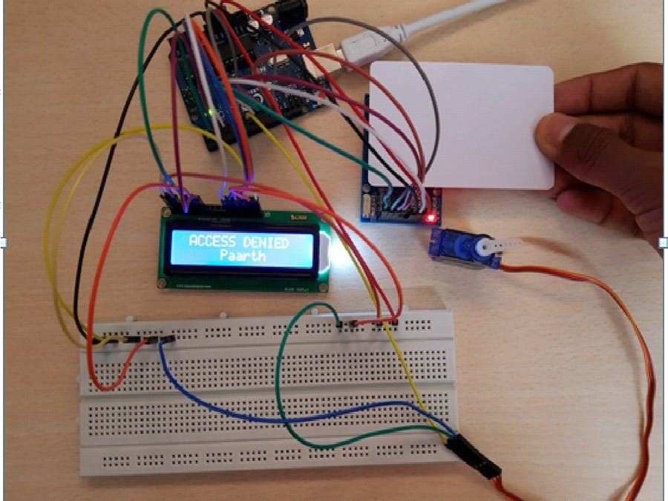

Figure 1.1 RFID Door Lock

1. Advantage:

* User can access use Rfid cad only
* Can acces multiple database

1. Disadvantage

* Cannot connect to mobile phone
* User can connect by rfid can only

7

*RFID door lock Servo motor*

b) Now as the tag is powered it can extract the transmitted message from the reader, and for sending message back to the reader, it uses a technique called load manipulation. Switching on and off a load at the antenna of the tag will affect the power consumption of the reader’s antenna which can be measured as voltage drop. This changes in the voltage will be captured as ones and zeros and that’s the way the data is transferred from the tag to the reader.

There’s also another way of data transfer between the reader and the tag, called backscattered coupling. In this case, the tag uses part of the received power for generating another electromagnetic field which will be picked up by the reader’s antenna.

1. Advantage

* Character display

1. Disadvantage

* Servo motor is not strong enough to lock the door
* The door can’t be access if rfid card missing.

8

*Personal RFID lock*

c) An RFID based Door Lock is based on some simple concepts. We store a set of RFID card data in our system, say 3 or 10 RFID card data. When the person with the right RFID card (compatible to data preloaded in our program/system) come and swipes his RFID tag, access will be granted. When the person with the wrong RFID card (whose data is not loaded in our system) swipes his RFID tag, access will be denied. I hope you understand the system concept of RFID based Door Lock

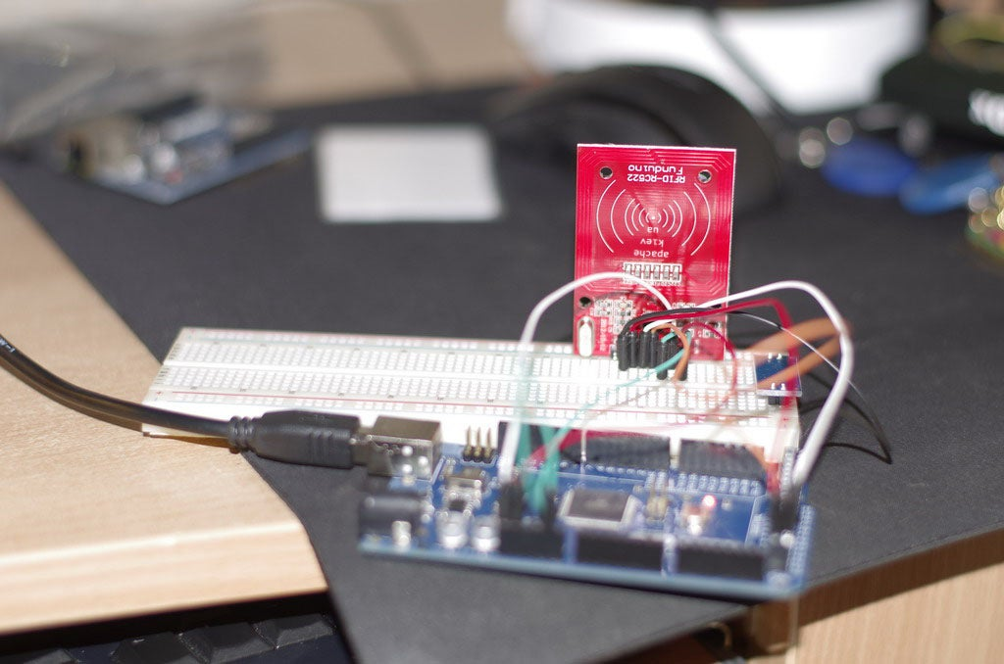

Figure 1.2 Personal RFID lock

1. Advantage

* User easy to access by RFID Card Only
* No more key to open the door

1. Disadvantage

* Don’t have multiple user database
* Can access by rfid card only

9

Table 1.2 RFID Door Lock

|  |  |  |  |  |
| --- | --- | --- | --- | --- |
| System Name  Function | RFID Door Lock | RFID door lock Servo motor | Personal RFID lock | Smart RFID Kamsis |
| Rfid Scanner | **✓** | ✓ | ✓ | ✓ |
| Multiple Database | ✓ | ✓ | ✕ | ✓ |
| Database | Mysql | Mysql | Mysql | Mysql |
| Mobile Application | ✕ | ✕ | ✕ | ✓ |
| Webbased interface | ✕ | ✕ | ✕ | ✓ |
| Notication system | ✕ | ✕ | ✕ | ✓ |
| Character Display | ✓ | ✓ | ✕ | ✕ |
| Log In System | ✕ | ✕ | ✕ | ✓ |
| User information on RFID card | ✕ | ✕ | ✕ | ✓ |

10

* 1. **Methodology**
     1. **Introduction**

Project management teams clung to the traditional approach of strict planning, process, and documentation. Agile management turns this approach on its head, and it’s no wonder that this methodology has become more popular over time. According to a 2017 study from PwC, agile projects are 28% more successful than traditional projects.And project managers have taken notice particularly among teams in industries like software development where technology, objectives, and targets are in constant flux.

**1.6.2 Rapid Application Development (RAD)**

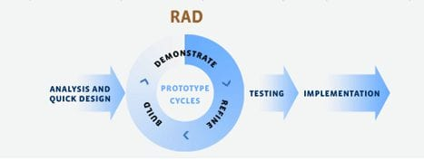The Rapid Application Development (or RAD) model is based on prototyping and iterative model with no (or less) specific planning. In general, RAD approach to software development means putting lesser emphasis on planning tasks and more emphasis on development and coming up with a prototype. In disparity to the waterfall model, which emphasizes meticulous specification and planning, the RAD approach means building on continuously evolving requirements, as more and more learnings are drawn as the development progresses.

Figure 1.3: Rapid Application Development

11

**1.6.3 Rapid Application Development Phase**

Phase 1 – Analysis

In this analysis phase,we choose our Polythechnic for our project at Pauh,Perlis. Then, we make an appointment on 17 august 2020. Then, interview the person in charge of the Kamsis Polythecnic. Ask question about lock system in kamsis .Lastly, list the current problem and find requirement of system.

Phase 2 – Design

In this design phase, create use case diagram to show the functionality of system, create Entity Relationship Diagram (ERD) to represent the data in database, create Data Flow Diagram to show the data flow involved in the system, create context diagram and create interface of system.

Phase 3 – Development

In this development phase, we create web based interface for admin, staff and student’s, create system by using Arduino, create database by using Xammp Server Mysql and create connection database.

Phase 4 – Testing

In this phase, will test database and developed a program to access the system built. The system developed will be accessed nodemcu it can operate perfectly or not. The system will be tested to determine if there is any error in system developed.

12

* 1. **Gantt Chart**

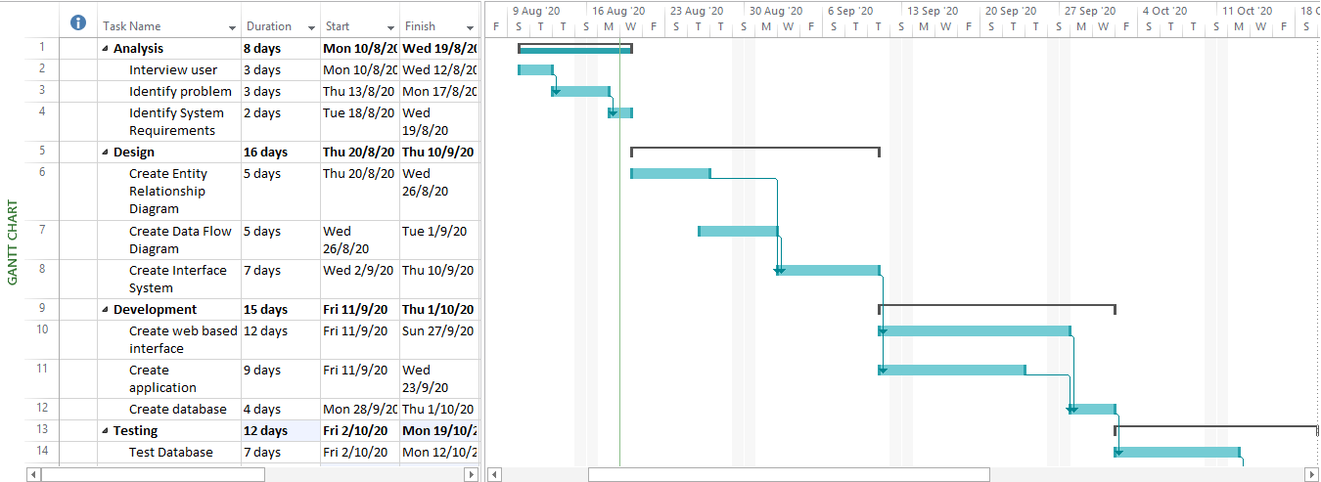

Figure 1.4 Gantt Chart

13

**2.0 REQUIREMENT SPECIFICATION**

**2.1 Functional Requirement**

A Functional Requirement is describes the functions a software must perform. A function is nothing but inputs, its behavior, and outputs. It can be a calculation, data manipulation, business process, user interaction, or any other specific functionality which defines what function a system is likely to perform.

1)Register Student - Admin register students who get kamsis.

2)Add Facilities detail - Staff can add details number code .

3)Student is able to open the door with matrik card.

- Log into the system.

- Admin update and delete students.

-Admin and Admin can view student login

-Admin can view the facilities details.

-Staff can view and delete students details.

-Staff can update facilities details

-Students must confirm the facilities at room.

-Student update profile.

- Student can change the password.

-Finally,logout.

**2.2 Non Functional Requirement**

A non-functional requirement is a requirement that specifies critiea that can be usedto judge the operation of a system, rather that specific behaviors. they are contrasted with functional requirements that define specific behavior or function. The plan for implementing functional requiremnts is detailedin the system architecture,because they are usually architecture significant requirements.

2.2.1 Reliability

Reliablity is how often does the system experience critical failures and how much time is it available to users against downtimes?

A) The system shall be complete operational at least 80% of the time.

B) Down time after a failure shall not exceed 48 hours.

C) The system must successfully add any register provided by the user and provideestimates and inventory status at in relation to a newly update entity.

D) The system must confirm student fees by staff and access the matrix card as a key.

14

**2.3 Hardware and Software Requirement**

Table 2.1: Software

|  |  |
| --- | --- |
| **Software** | **Explaination** |
| Arduino IDE | Program And set up Arduino Uno |
| Notepad Plus | To create web based interface |
| Xammp Server Mysql | Create Database |

Table 2.2 : Hardware

|  |  |
| --- | --- |
| Hardware | Explaination |
| 1. MRFC RFID522 RFID Scanner | To read RFID card |
| 1. 12V DC Solenoid Door Lock | electrical locking and unlocking |
| 1. Nodemcu EPS8266 | To control a digital output |
| 1. 2Channel Isolated 5V Relay(BT13-003) | allows a relatively low voltage to easily control higher power circuits |
| 1. breadboard | make quick electrical connections between components |
| 1. Jumper cable 150mm | open or bypass part of an electronic circuit |
| 1. 12V Battery | Supply power to Arduino |
| 1. Led | Light will on went solenoid open |
| 1. Buzzer | Turn on door is open |
| 1. Pine wood | For design door |
| 1. Pir sensor | PIR sensors are commonly used in security alarms and automatic lighting applications. |

**15**

**2.4 System Configuration**

A system configuration (SC) in systems engineering defines the computers, processes, and devices that compose the system and its boundary. More generally, the system configuration is the specific definition of the elements that define and/or prescribe what a system is composed of.

1. User login to the system as admin,staff or students by inserting username and password then press the login button.
2. If user forget their password,click button forgot your password link.
3. If login seccesfull, admin need to register student details and staff details.
4. The information message will appear to let user know the data has been saved.
5. To update ,delete , and confirm just click the button.
6. Admin can view students detail,staff detailsand facilities detail.
7. Staff can view student detail and confirm the fee students.

**2.5 Security Requirement / Exceptional Handling**

In computing and computer programming, exception handling is the process of responding to the occurrence of exceptions – anomalous or exceptional conditions requiring special processing - during the execution of a program. In general, an exception breaks the normal flow of execution and executes a pre-registered exception handler; the details of how this is done depend on whether it is a hardware or software exception and how the software exception is implemented. It is provided by specialized programming language constructs, hardware mechanisms like interrupts, or operating system (OS) inter-process communication (IPC) facilities like signals. Some exceptions, especially hardware ones, may be handled so gracefully that execution can resume where it was interrupted.

LOG IN

- Stock Alert System provide user authorization for login

-Stock Alert System provide alert message for wrong input username and password.

16

**3.0 FINAL DESIGN**

**3.1 Logical Design**

In the project smart rfid kamsis system at ptss , we use 3 user such as Admin,Staff and Student.At First, admin will register students and staff will be approved student fee. Also,Student can access room key with matrik cad.

1. DATA FLOW DIAGRAM

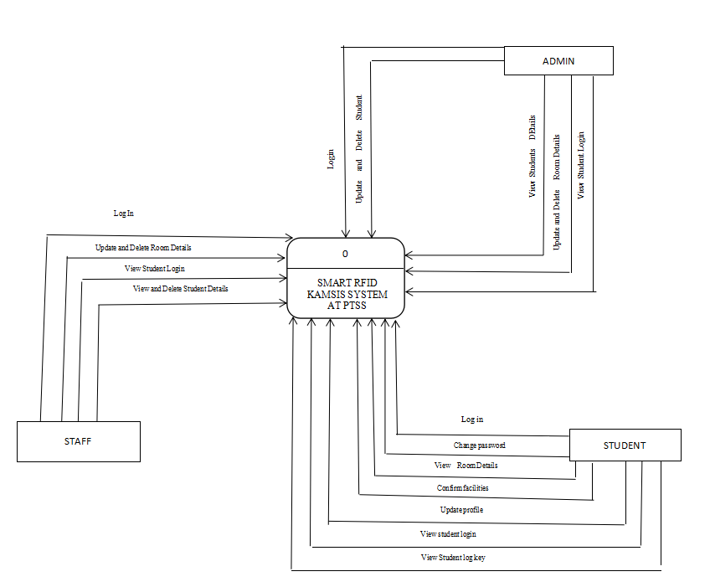

Figure 3.0 Data flow diagram

17

1. CROW FOOT

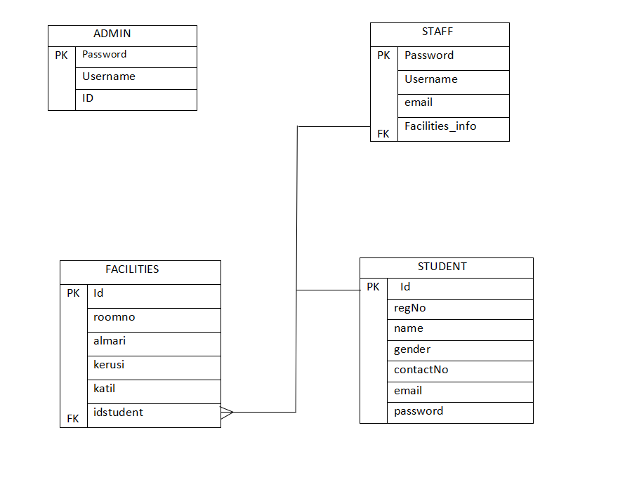

Figure 3.1 Crow Foot

18

3)FLOW CHART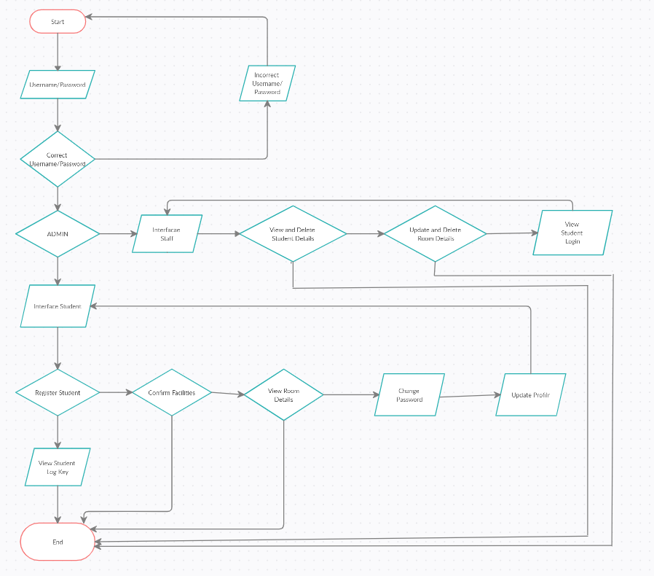

Figune 3.2 Flow chart

19

**3.2 Physical Design**

Physical design is a step in the standard design cycle which follows after the [circuit design](https://en.wikipedia.org/wiki/Circuit_design" \o "Circuit design). At this step, circuit representations of the components (devices and interconnects) of the design are converted into geometric representations of shapes which, when manufactured in the corresponding layers of materials, will ensure the required functioning of the components

**ADMIN INTERFACE**

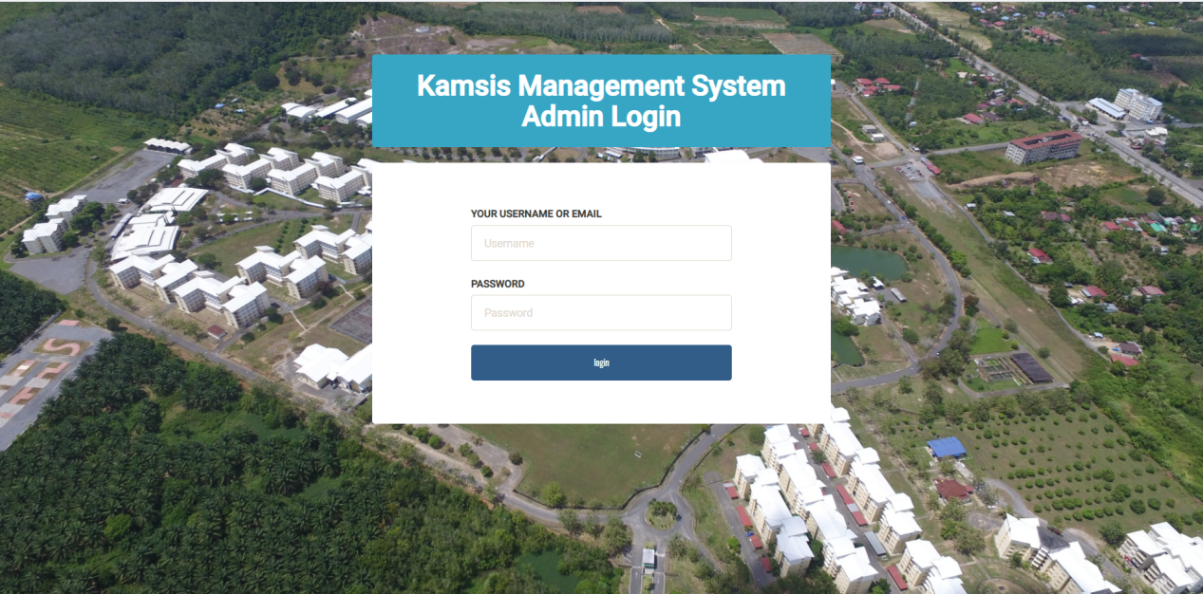

Figure 3.3 Admin Login

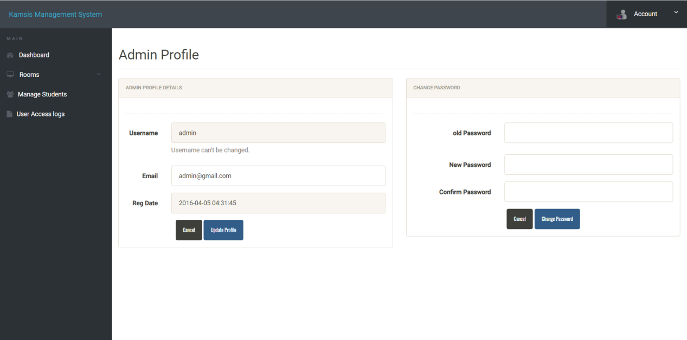

Figure 3.4 Admin Profile

20

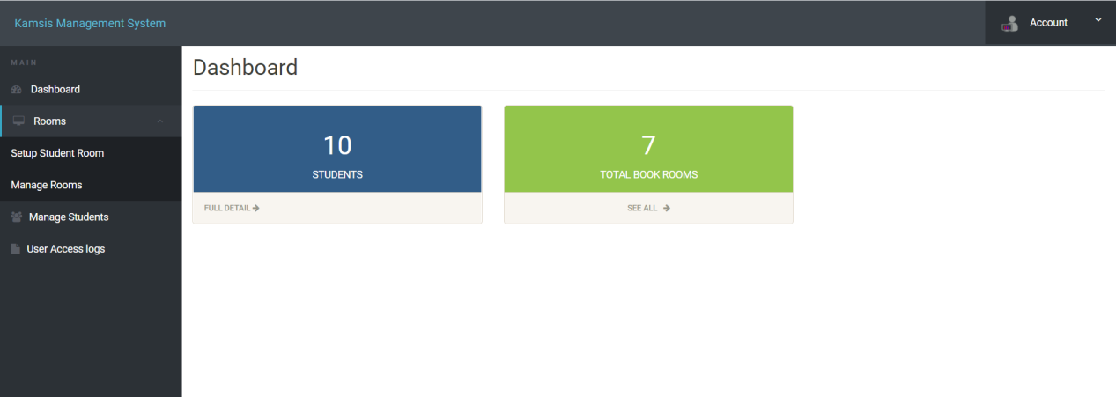

Figure 3.5 Dashboard Admin

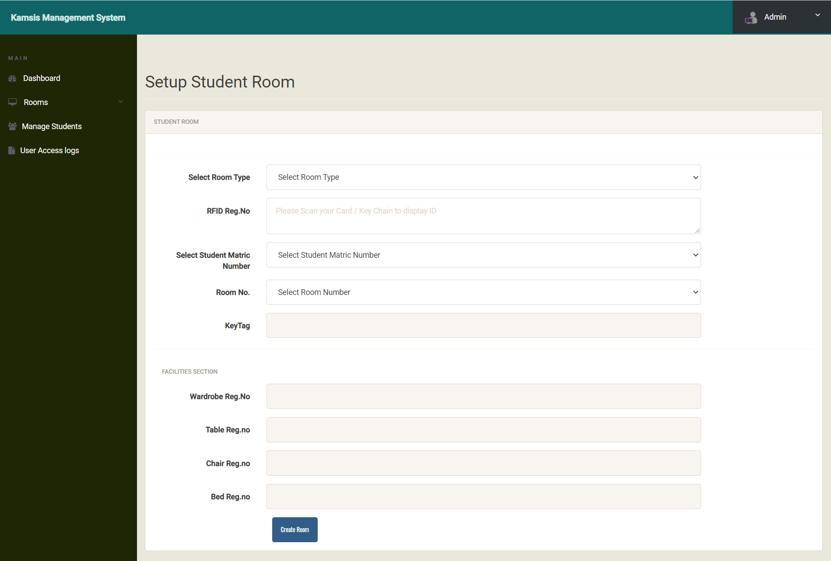

Figure 3.6 Setup Students Room

21

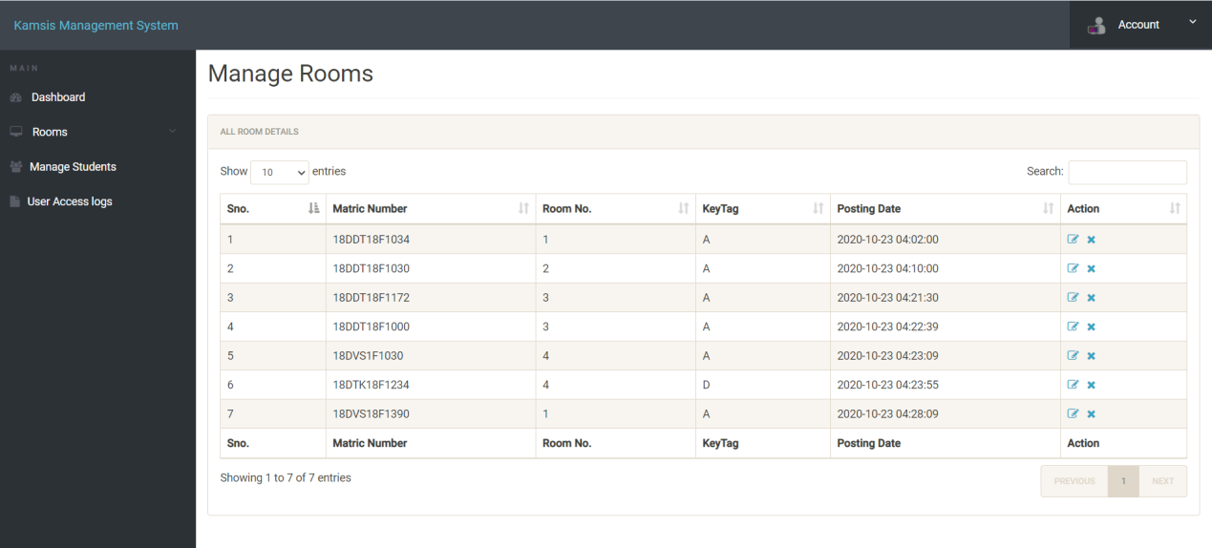

Figure 3.7 Manage Room

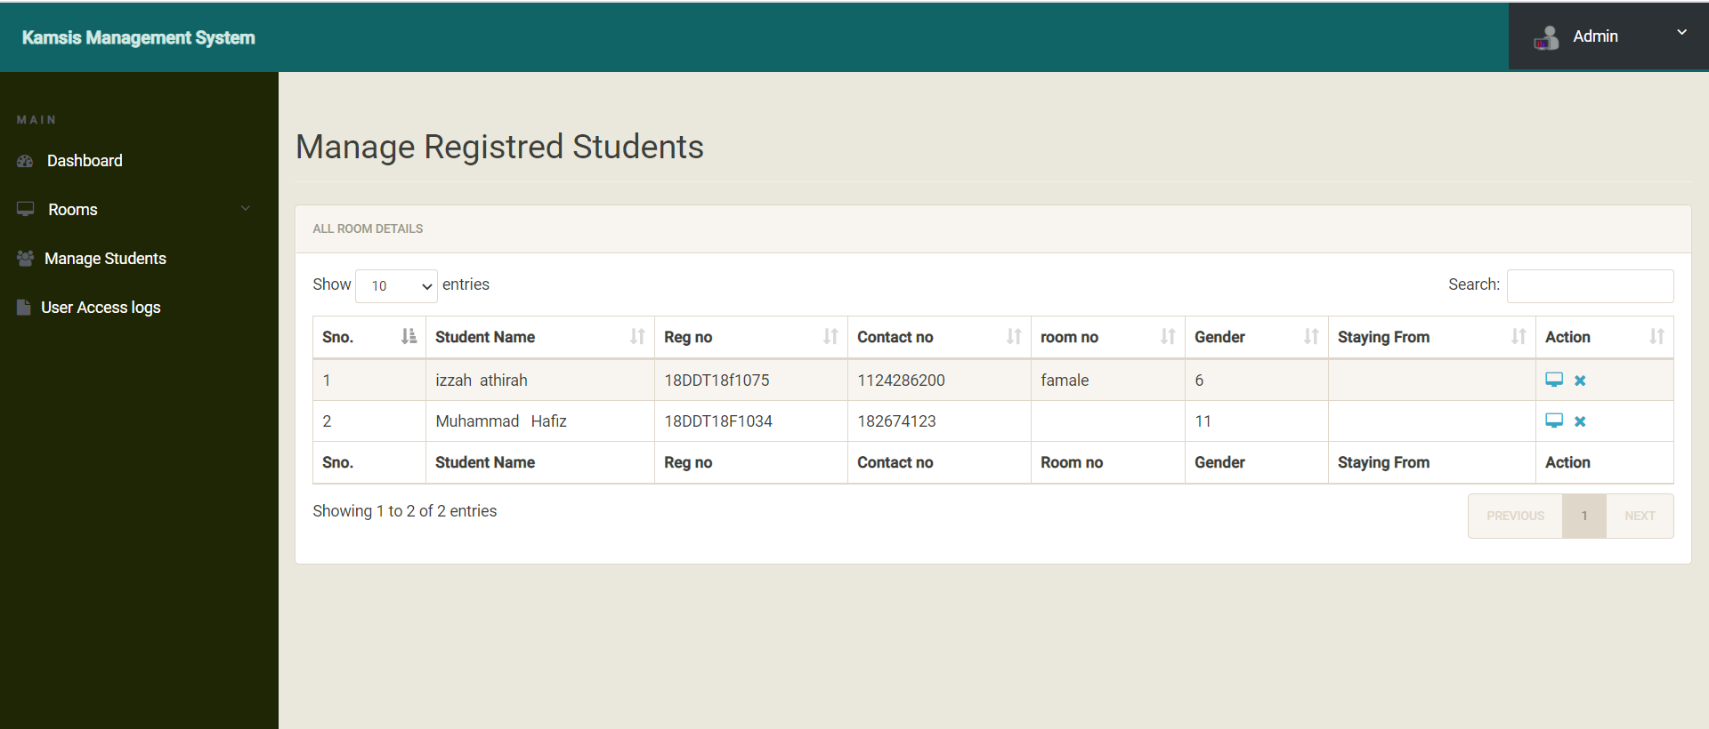

Figure 3.8 Manage Regidtred Student

22

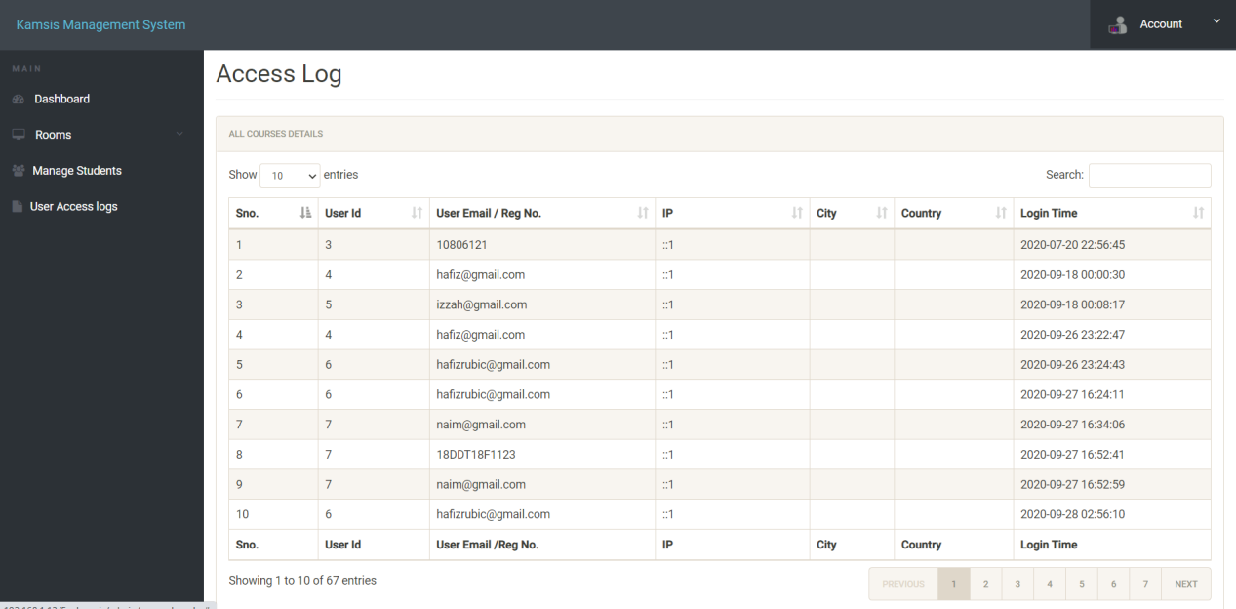

Figure 3.9 Access log

23

**WARDEN /STAFF INTERFACE**

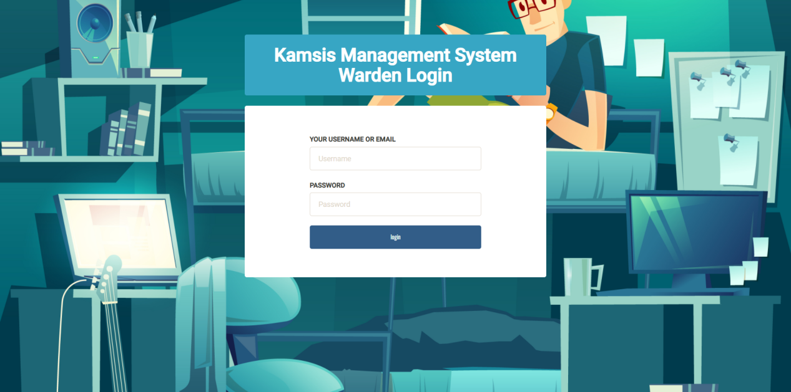

Figure 3.10 login warden

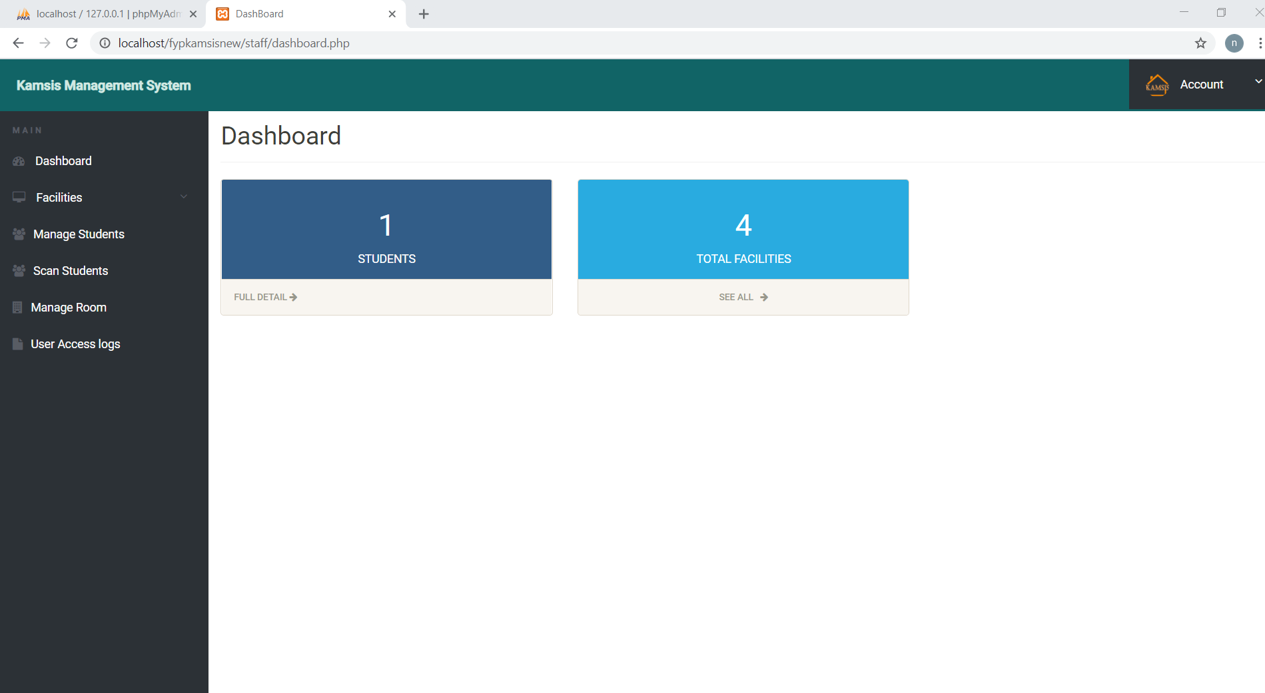

Figure 3.11 Dashboard Staff

24

1. STUDENT - Manage Registres Students

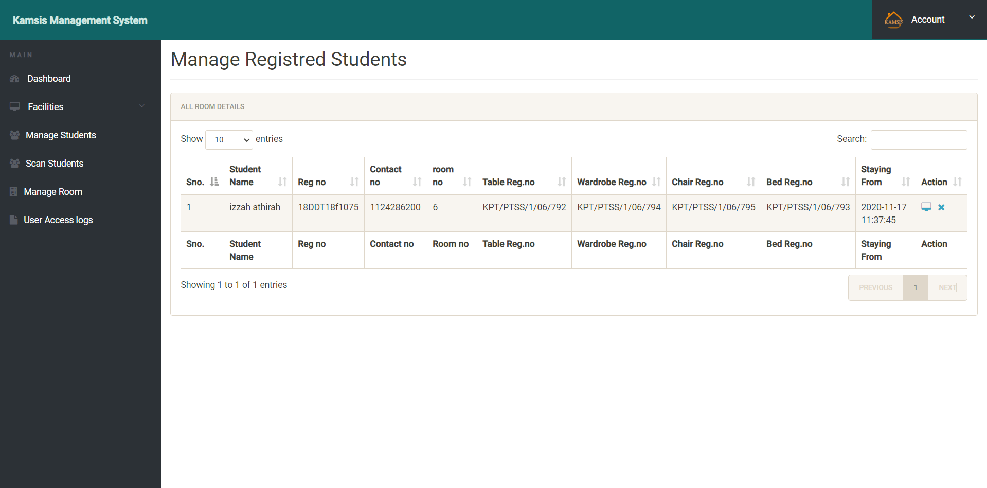

Figure 3.12 Manage Registred Students

1. Total Facilities

- Manage Facilities

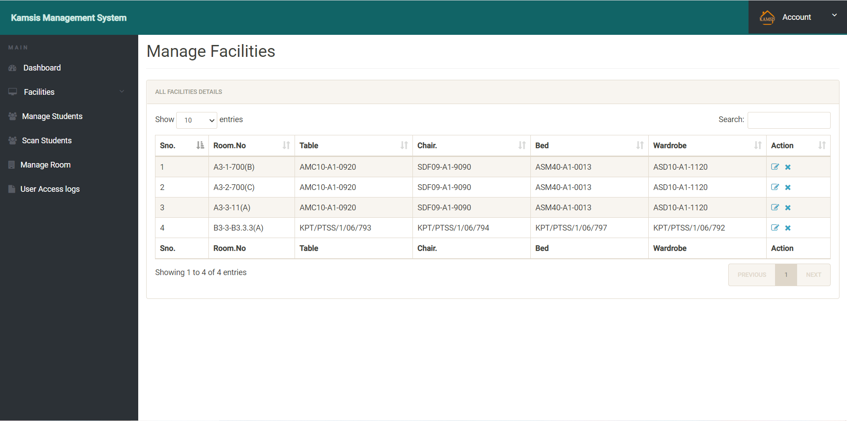

Figure 3.13 Manage Facilities

25

Facilities

- Add a Room Information

- Manage Facilities

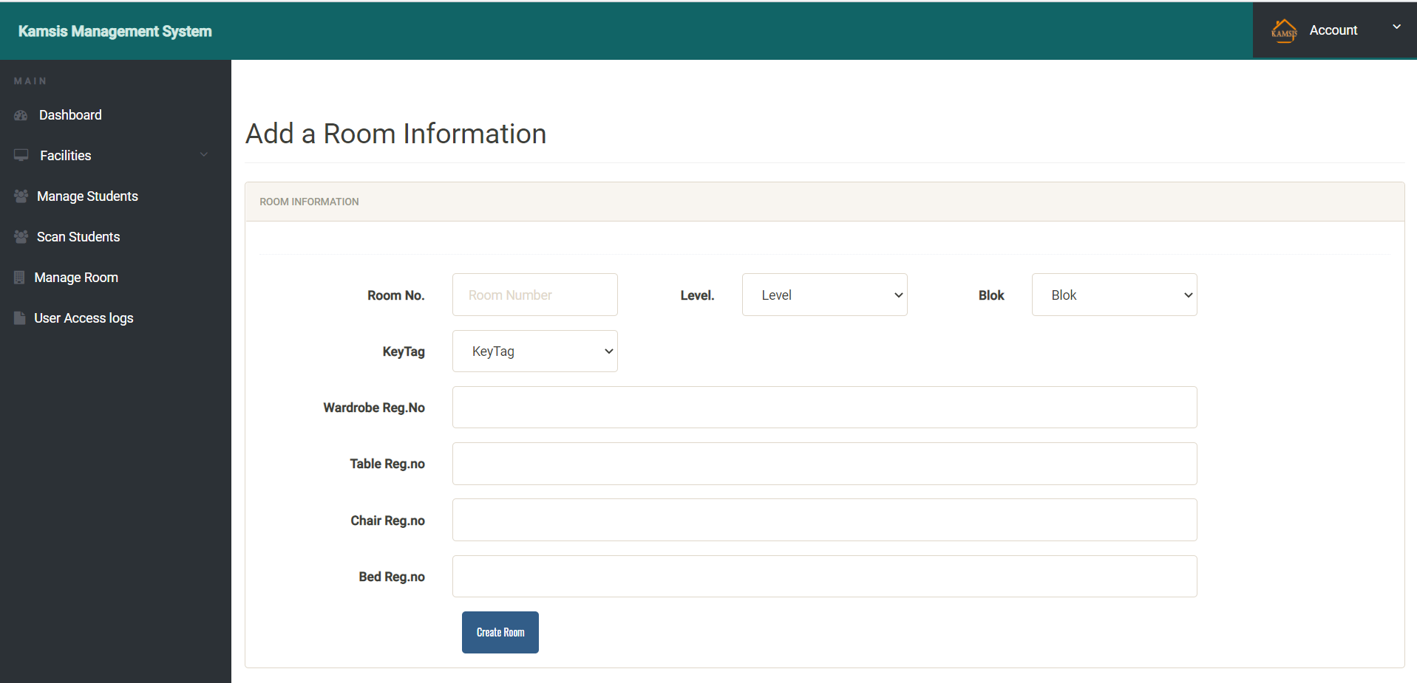

Figure 3.14 Add a Room Information

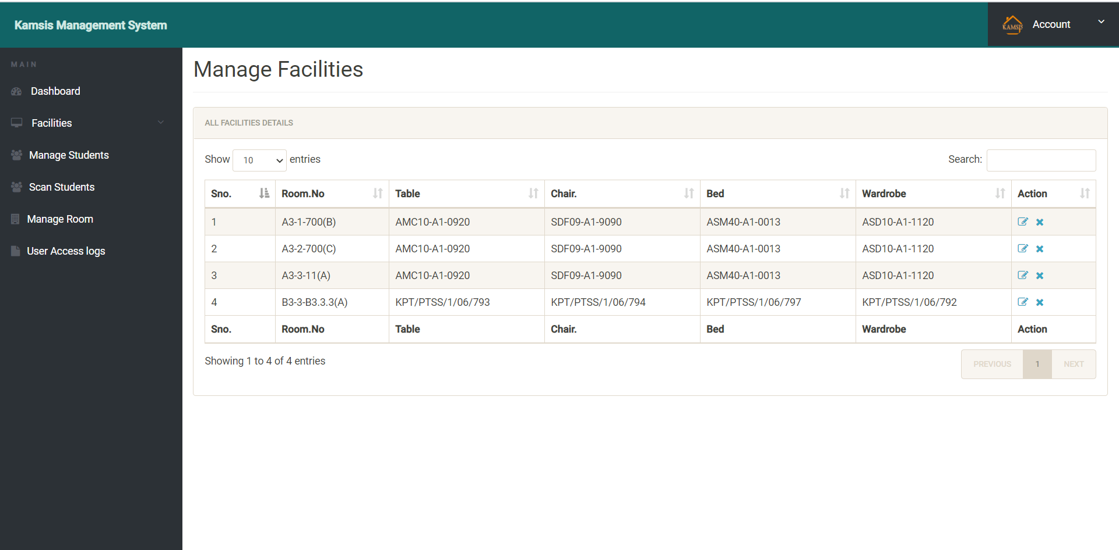

Figure 3.15 Manage Facilities

26

Manage Student

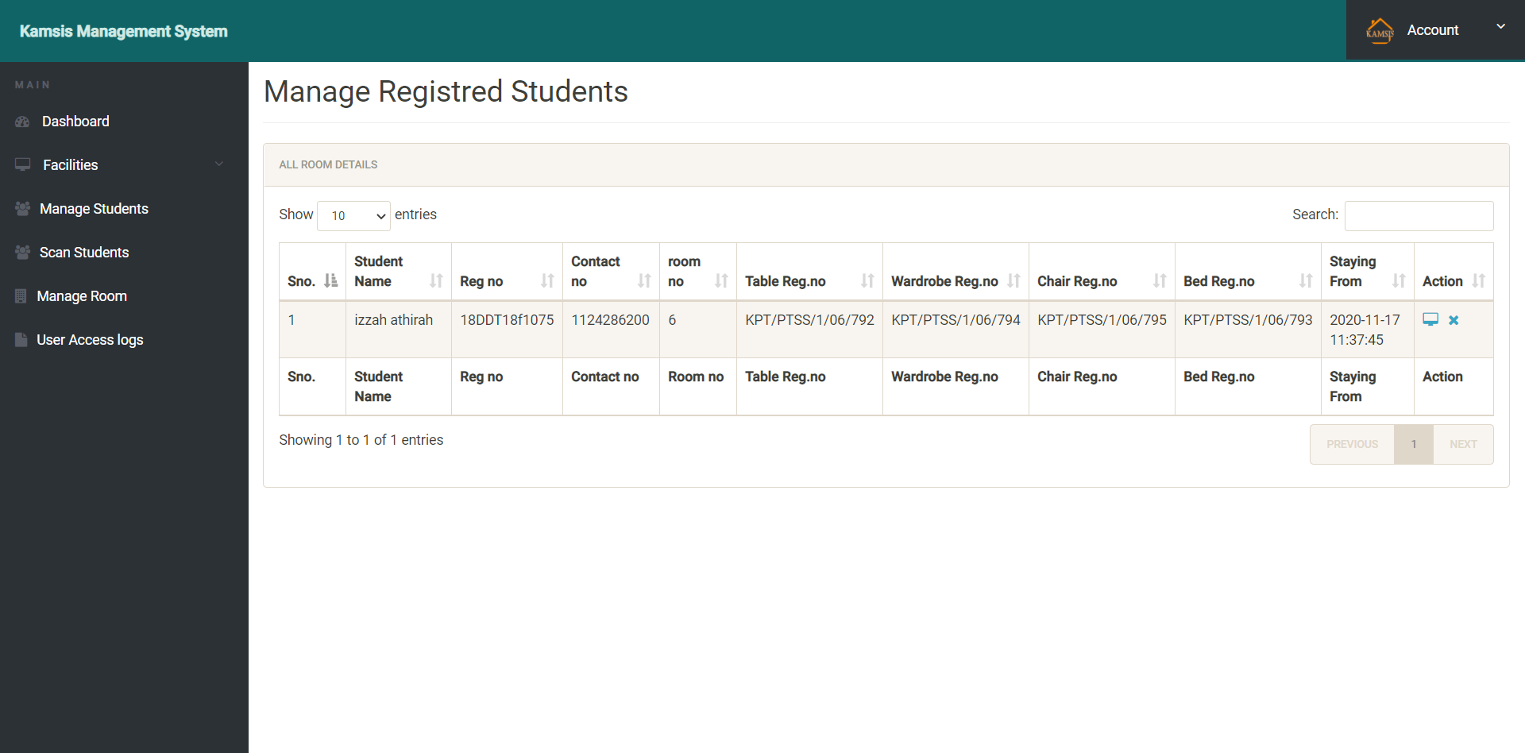

Figure 3.16 Manage Registred Student

Scan Students

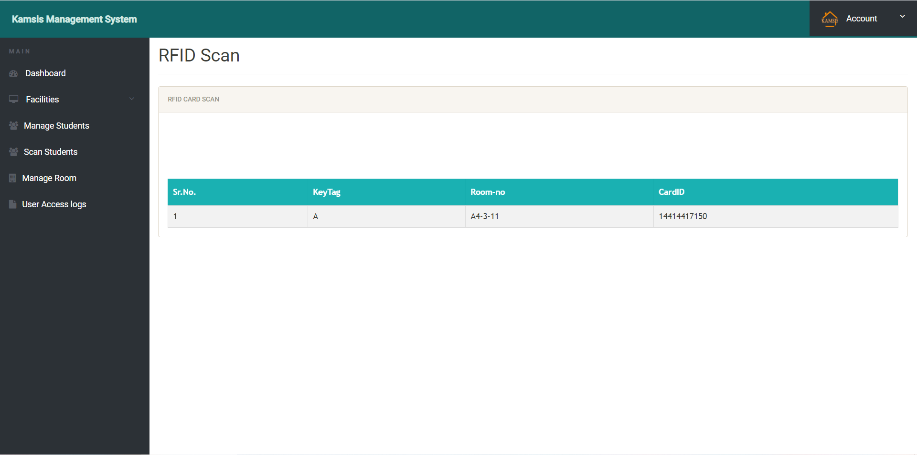

Figure 3.17 RFID Scan

27

Manage Room

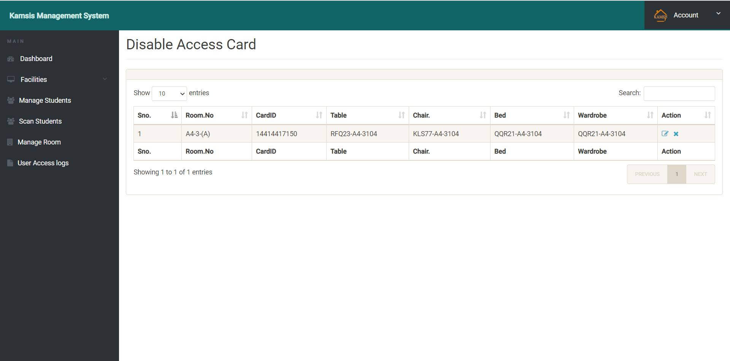

Figure 3.18 Disable Access Card

**User Access logs**

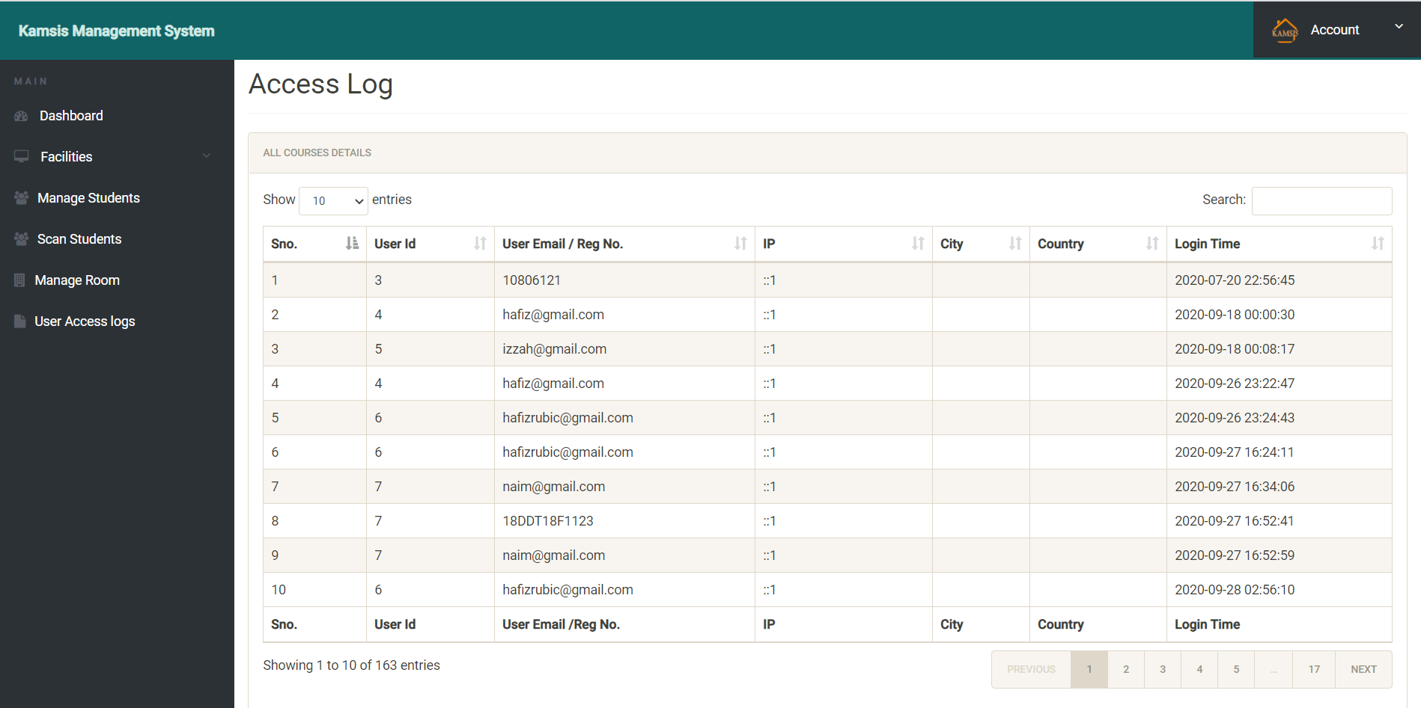

Figure 3.19 Access Log

28

Student Interface

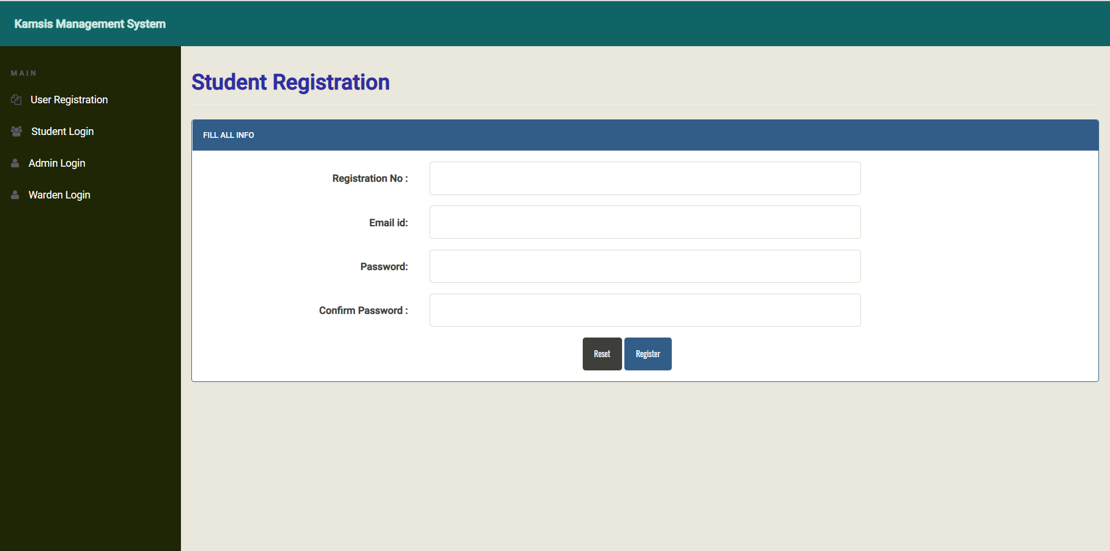

Figure 3.20 Student Registration

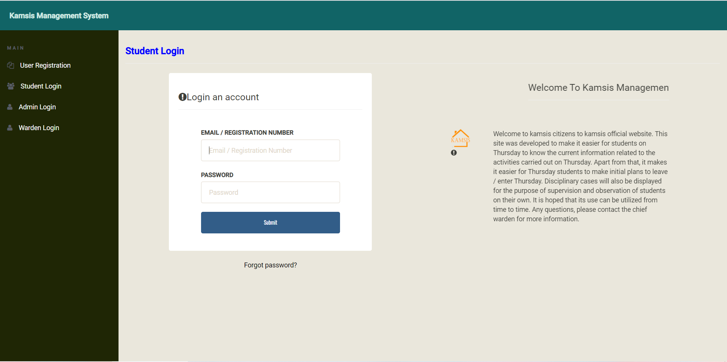

Figure 3.21 Student Login

29

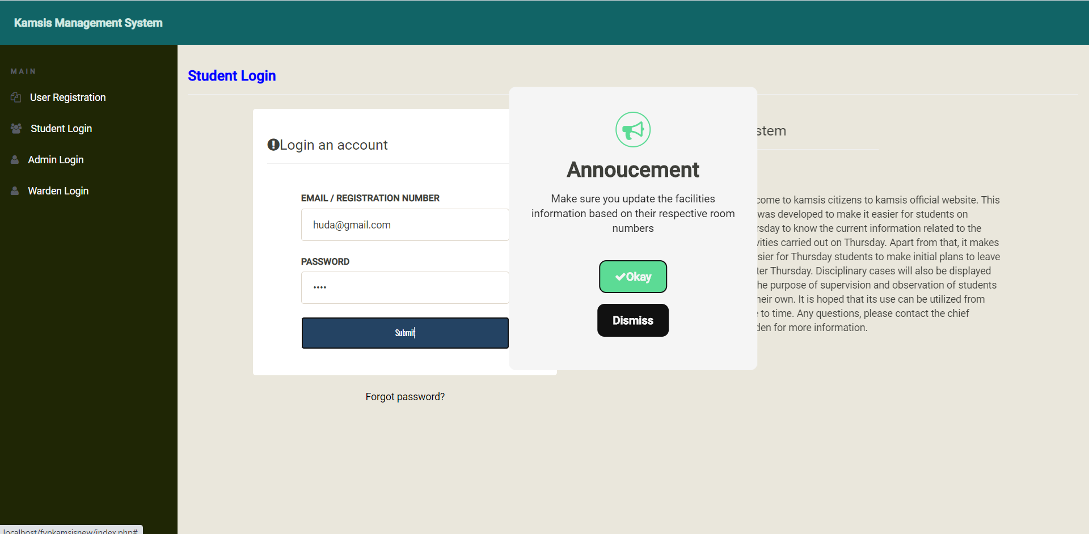

Figure 3.22 Annoucement to Student about update the facilities information.

DASHBOARD

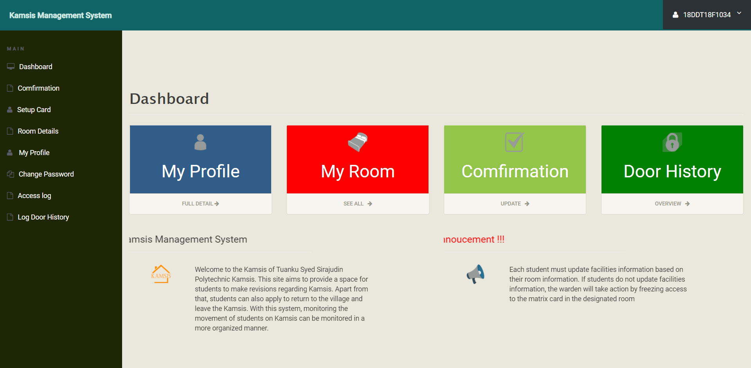

Figure 3.23 Dashboard student

30

1.My Profile -

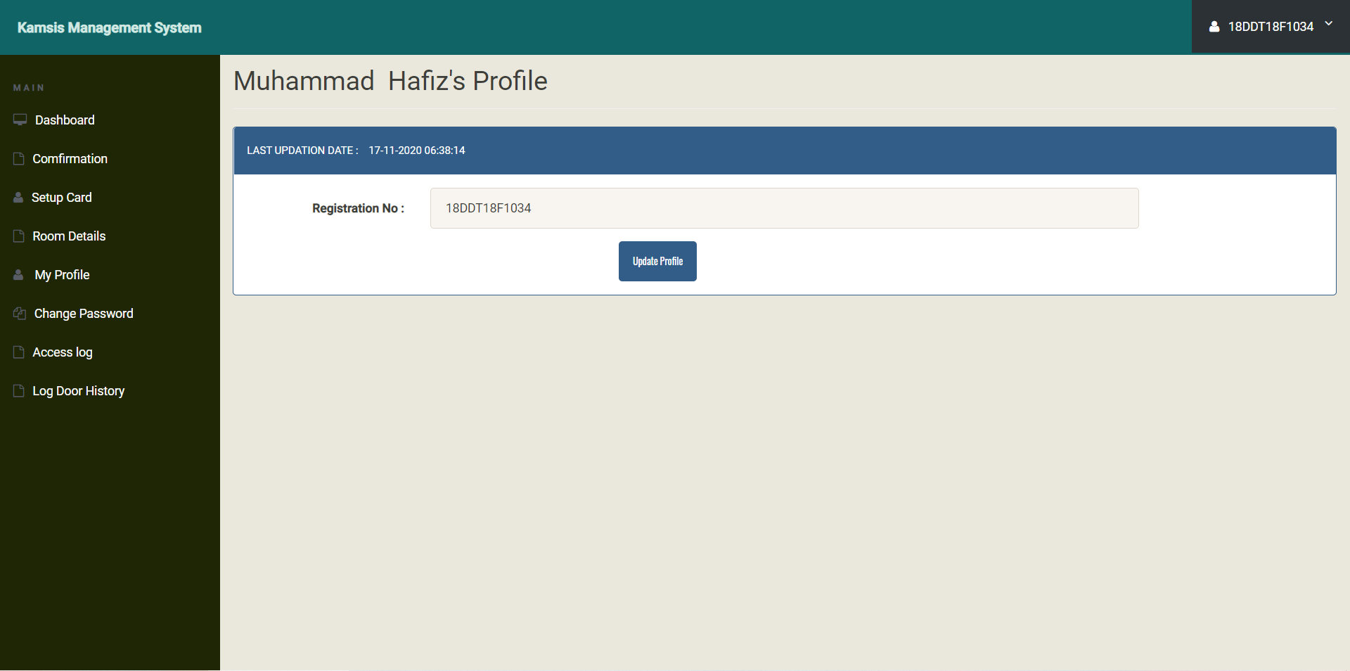

Figure 3.24 Student Profile

2.My Room

- Rooms Details

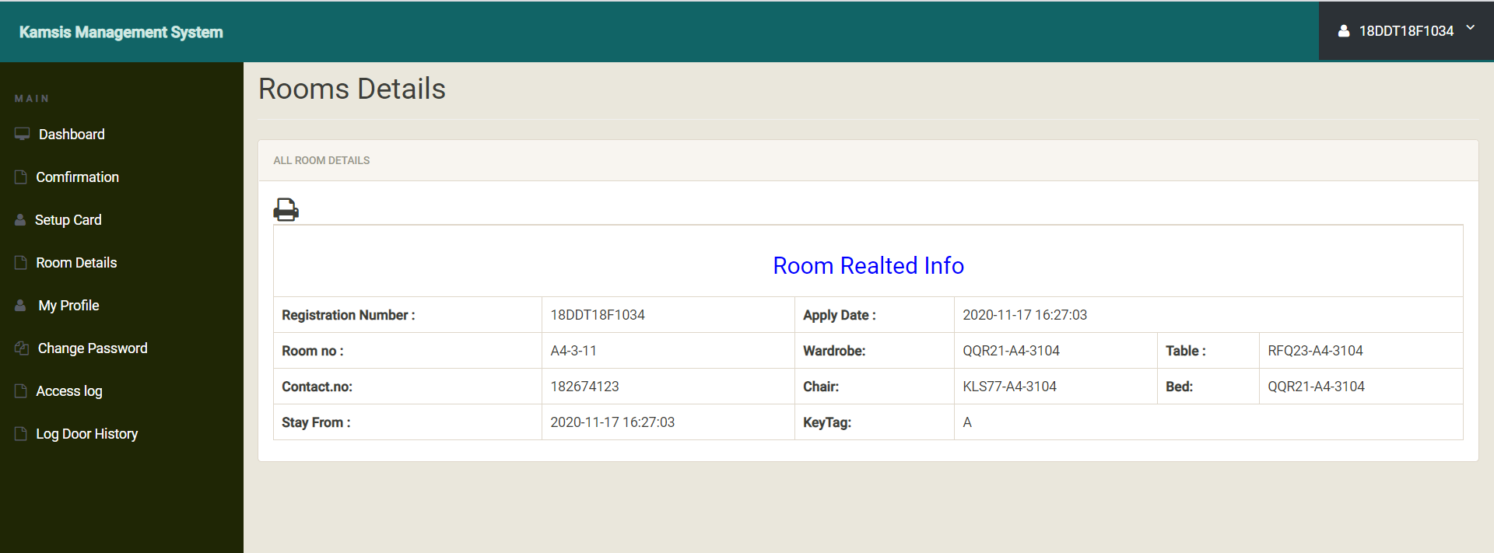

Figure 3.25 Room Details



Figure 3.26 Successfully card

31

3.Confirmation

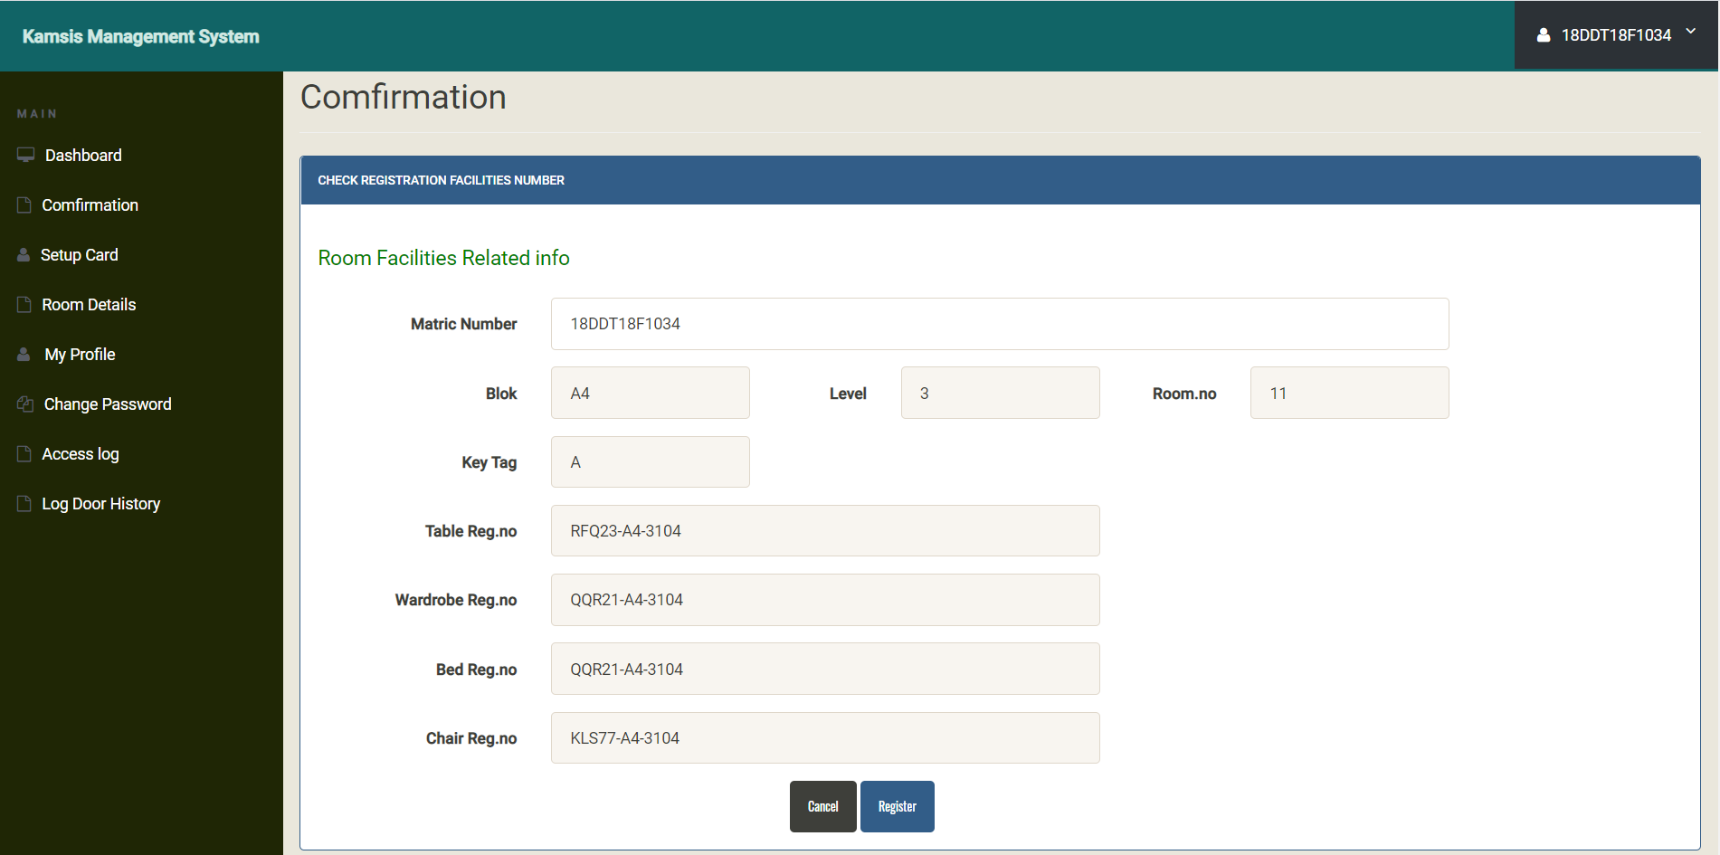

Figure 3.27 Confirmation information

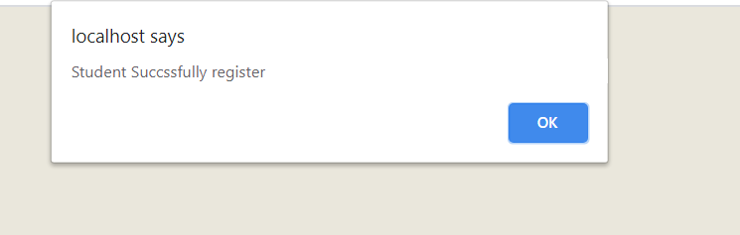

Figure 3.28 Student Succussfully register confirm about facilities.

Confirmation

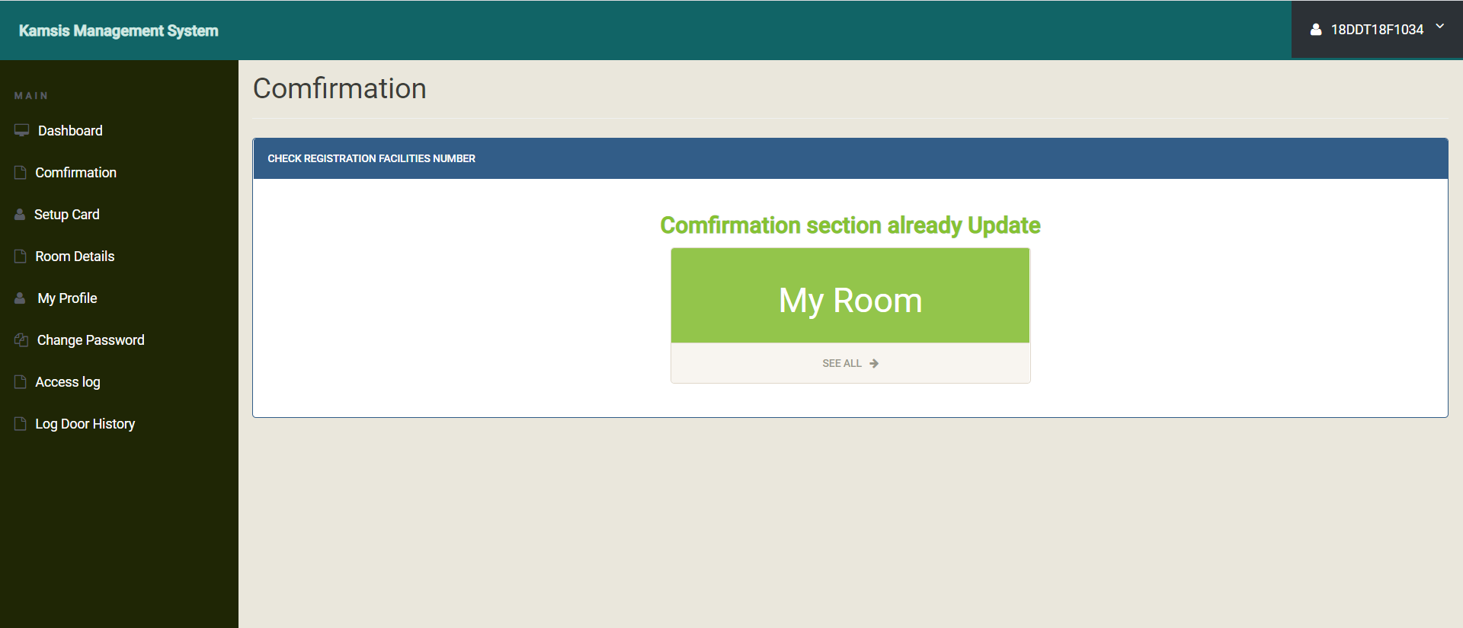

Figure 3.29 Confirmation already update

32

Room Details

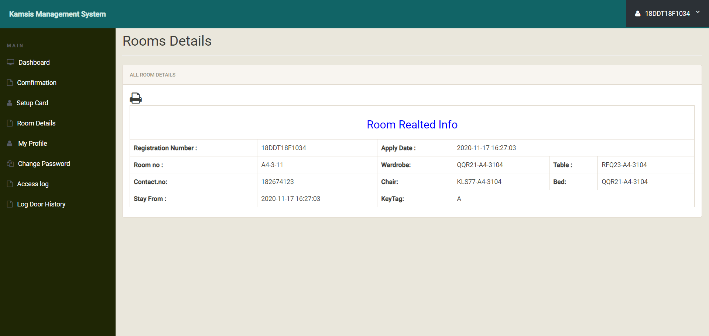

Figure 3.30 Room Realted Info

Setup Card

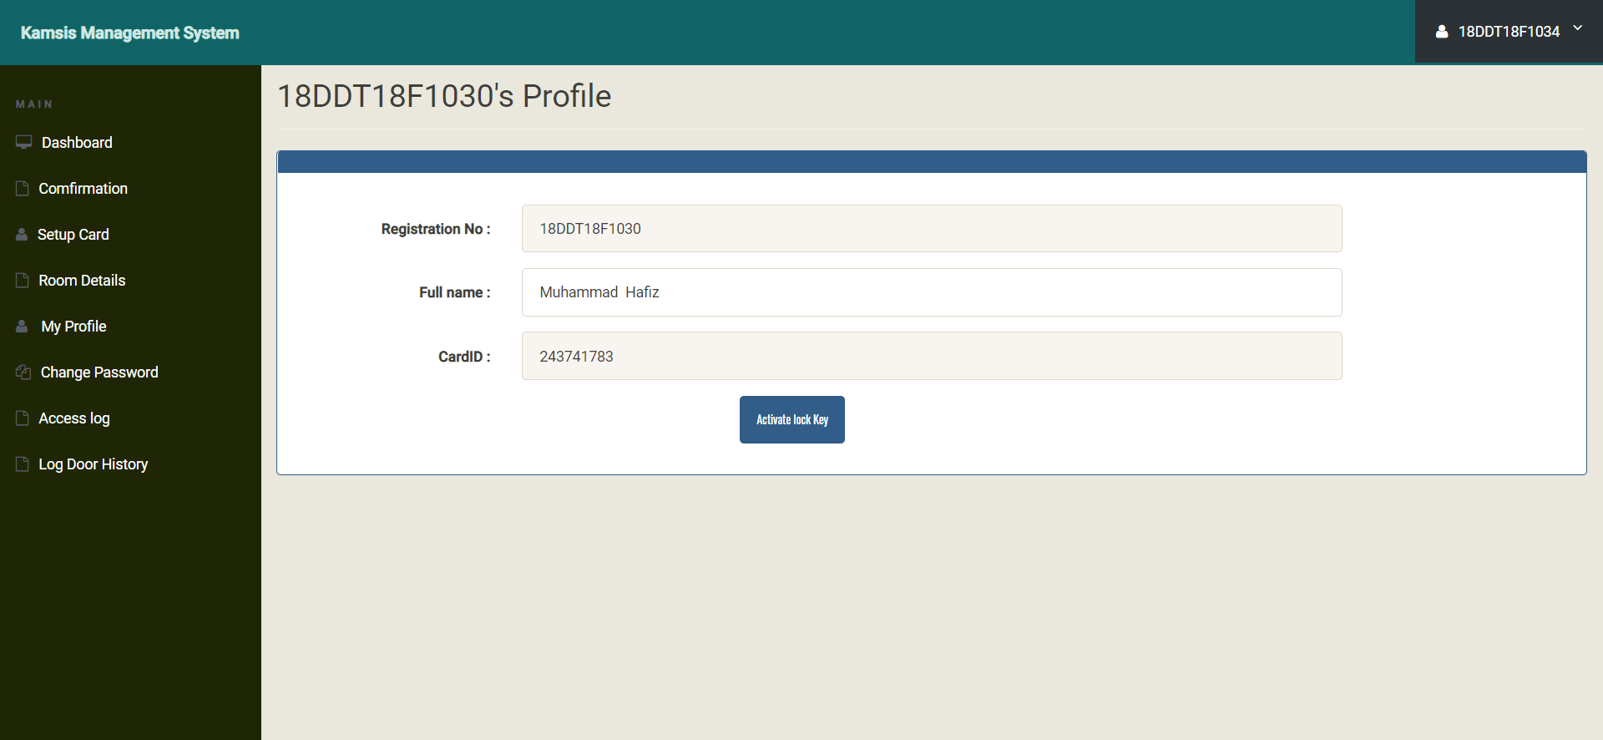

Figure 3.31 Activate lock key



Figure 3.32 Lock key is ready to use

33

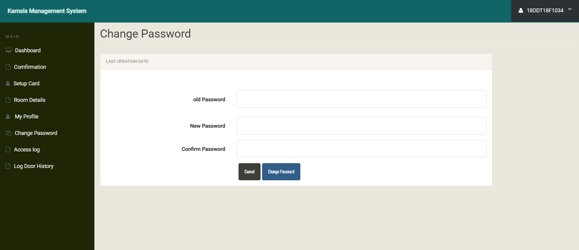

Figure 3.33 Change Password

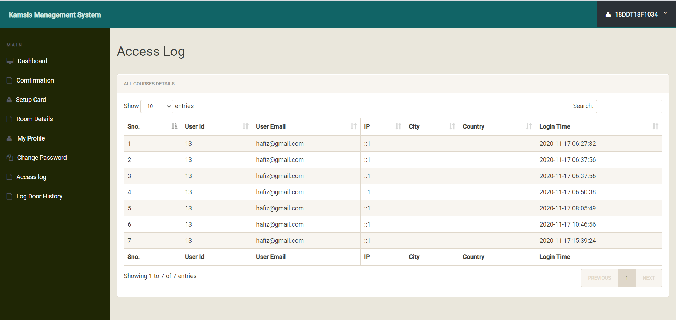

Figure 3.34 Acces log

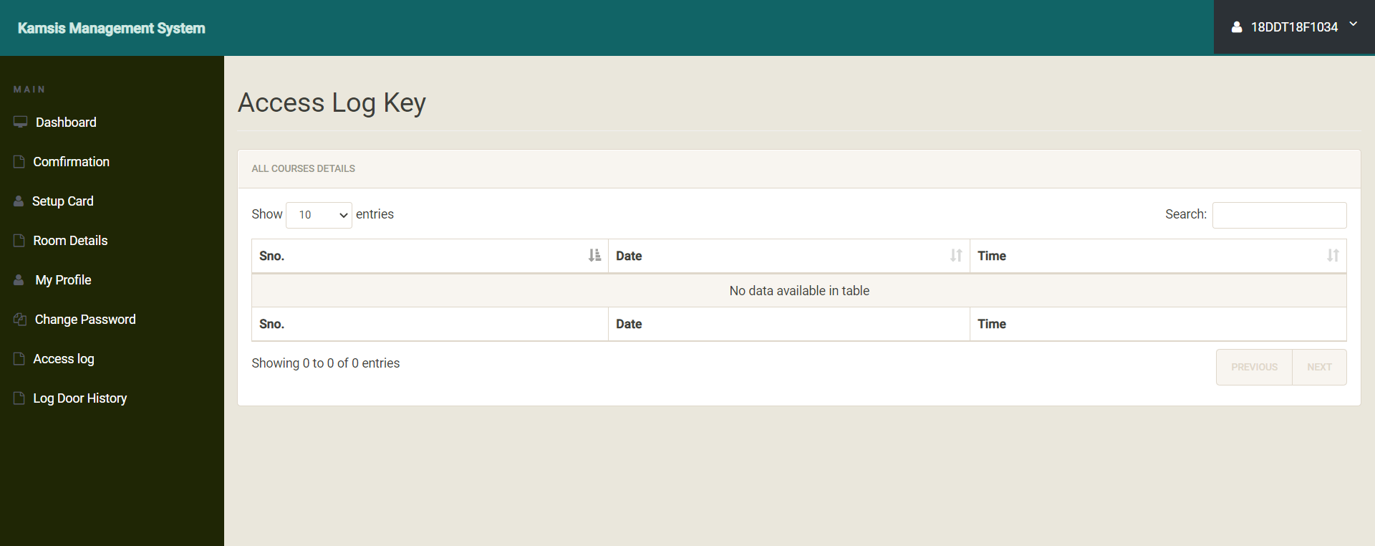

Figure 3.35 Access log key

34

Hardware :

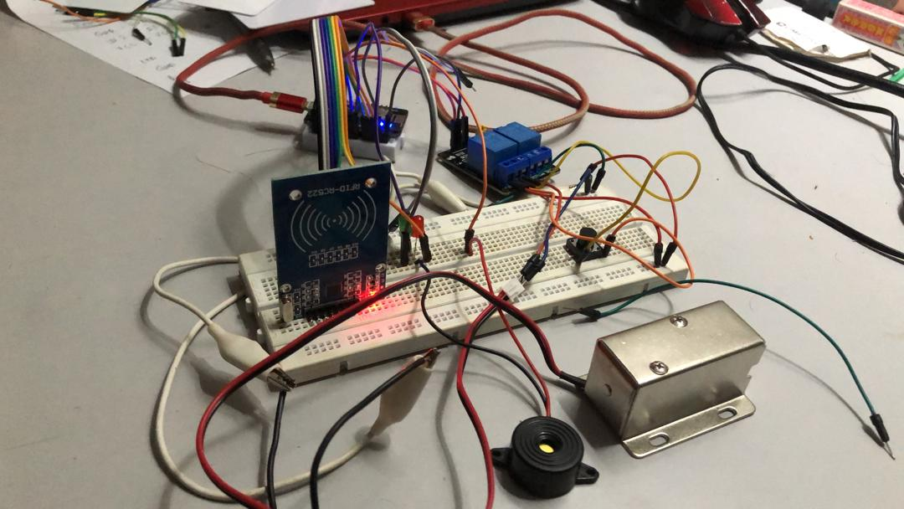

Figure 3.36 hardware compenent

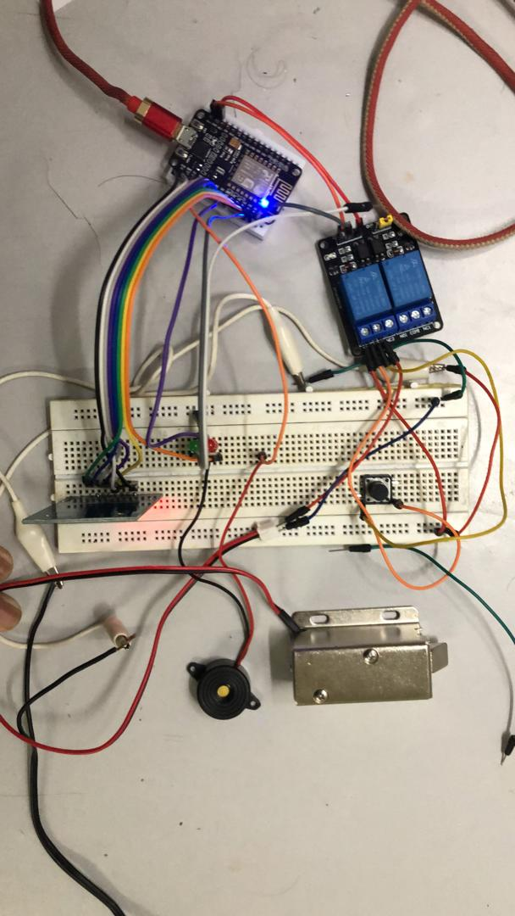

Figure 3.37 hardware Compenent

35

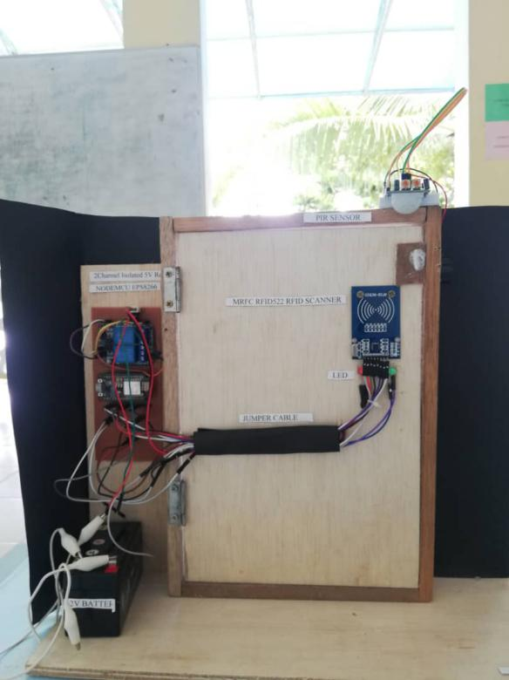

Figure 3.38. Hardware component with door

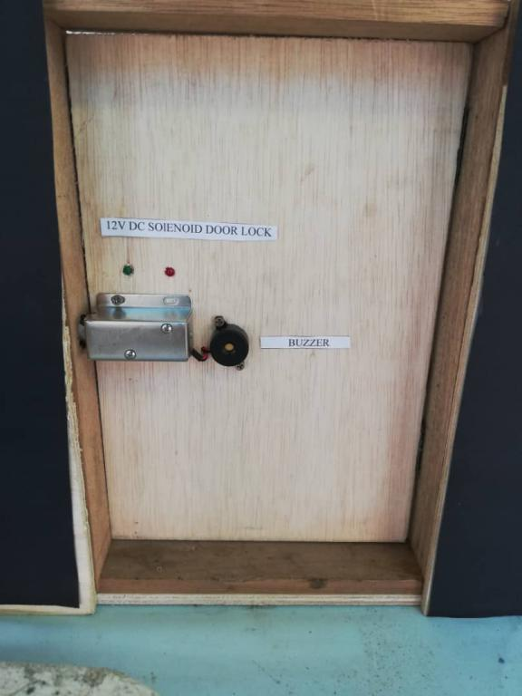

Figure 3.39 Solenoid door lock and buzzer

36

**4.0 TEST DESCRIPTION AND RESULT**

**4.1 Unit Testing Plan**

Table 4.1.Unit Testing Plan (UTP)

37

|  |
| --- |
| WEB SYSTEM INTEGRATION TESTING PLAN (UTP) |

|  |  |  |  |  |  |  |
| --- | --- | --- | --- | --- | --- | --- |
| No | Test Case  Name | Test  Procedure | Pre-  Condition | Expected  Result | Tester | Result  (Pass/Failure) |
| 1. | Login | User is required to fill the username and password.Also,  click  Button after fill username and password to access the system. | Username and password are already set in system without registration. | User will directly go to homepage after login. | Hafiz | Pass |
| 3. | Admin | Admin can update and delete staff details on website. | None | Positive successful update and delete student details. | Admin | Pass |
| 4 | Staff | Staff also can view and delete student  details on website,Also staff can update room details. | None | Positive successful  update and  Delete  student  details | Jamilah | Pass |
| 4 | Student | Student also can update and confirm room  details on website | None | Positive successful  update and  delete student  details | Izzah | Pass |
| 4. | Logout | User logout from the system by click logout button. | None | User will directly go to login page after clicking button logout. | Hafiz | Pass |
| 5. | Update | Admin can update data student.Click Button update. | Students details are already set in system. Click button Update to change data. | notifications wil review pop up and the data will change automatically in user page. | Kedah to Selangor | Pass |
| 4. | Delete | Admin can delete data student.Click Button delete. | Students details are already set in system. Click button Update to change data. | notifications wil review pop up and the data will delete automatically in user page. | none | Pass |

**38**

**Unit Test Plan (UTP) - Smart Rfid Kamsis System At Ptss**

**Table 4.2 Integration Testing Plan**

|  |  |  |  |  |  |  |
| --- | --- | --- | --- | --- | --- | --- |
| **WEB SYSTEM UNIT TESTING PLAN (UTP)** | | | | | | |
| **No.** | **Test Case Name** | **Test**  **Procedure** | **Precondition** | **Expected**  **Result** | **Tester** | **Result**  **(Pass/Failure)** |
| 1. | Scan RFID  card | Lock key can open with rfid card | None | Positive:  User can scan RFID easily using the nodemcu and the lock can be open easily.  Negative:  The lock cannot be displayed when the user is not owner the room | Hafiz | Pass |
| 2. | Scan multiple Rfid card | The Rfid can be used to scan multiple rfid easily if them is owner the room. | None | Positive:  Different owner of rfid can be displayed in lock key if them is owner the room.  Negative:  Cannot open the lock key. | Izzah | Pass |

**39**

RESULT TESTING HARDWARE

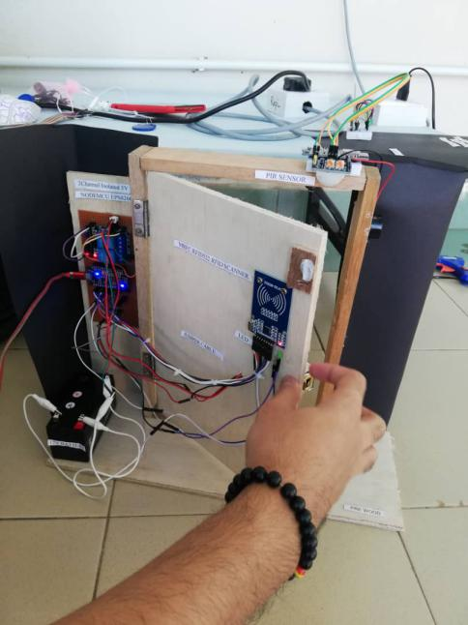

Figure 4.0 result testing

**5.0 DISCUSSIONS**

**5.1 Advantages of the Project**

The advantages of the project are :

1) To make things easier for student because student can easy open door to access by RFID Card Only.

2) To make things easier for staff because staff no need to create a new key when lost.

3) To make things more easier for staff because staff can view the facilities room detail.

**5.2 Limitation of the Project**

The system only uses student information and room information for students who open the room door and use the intrusion room.

40

**6.0 Conclusion**

The implementation of door access system is considered to be a need for a building especially companies to have a security system in order to keep the people inside and assets to be safe from unwanted cases such as burglaries,

Also, a smart lock system is presented which is a novel access control system using IOT which includes the online monitoring. The smart lock system provide a convenient way to automate the access control feature thereby enhancing security . It is a low cost, flexible, and a very easy to install system with no overhead like planning, cabling, and construction works.

41

**7.0 REFERENCE**

**E-BOOK**

1. SHUHADA NATASHA BINT MOHD ZAINOR, “DOOR ACCESS SYSTEM – ARDUINO BASED”,September 2012.
2. Shrinidhi Gindi1, Naiyer Shaikh, Kashif Beig, Abdeali Sabuwala, “Smart Lock System Using RFID”, International Research Journal of Engineering and Technology (IRJET),July 2020.
3. Ramalatha, M., Ramkumar, A. K., Selvaraj, S. and Suriyakanth, S, (2014), “RFID Based Personal Medical Data card for Toll Automation”. Elysium Journal Engineering Research and Management. Volume1, ISSN: 2347-4408, pp 51-52.
4. Umar Farooq, Mahmood ul Hasan, Muhammad Amar, Athar Hanif, and Muhammad Usman Asad, (2014), "RFID Based Security and Access Control System" IACSIT International Journal of Engineering and Technology, Vol. 6, No. 4, August 2014.

5.Peter Adole1, Joseph M. Môm and Gabriel A. Igwue, (2016), "RFID Based Security Access Control System with GSM Technology", American Journal of Engineering Research (AJER) e-ISSN: 2320- 0847 p-ISSN: 2320-0936 Volume-5, Issue-7, pp-236-242.

6.Dejan Nedelkovski, (2017), "How RFID Works and How To Make an Arduino based RFID Door Lock - HowToMechatronics”

WEBSITE

1. <https://www.elprocus.com/automatic-door-lock-system-using-rfid-and-arduino/.>
2. https://www.hackster.io/o1991o/nodemcu-rfid-door-lock-1dfa34

42